[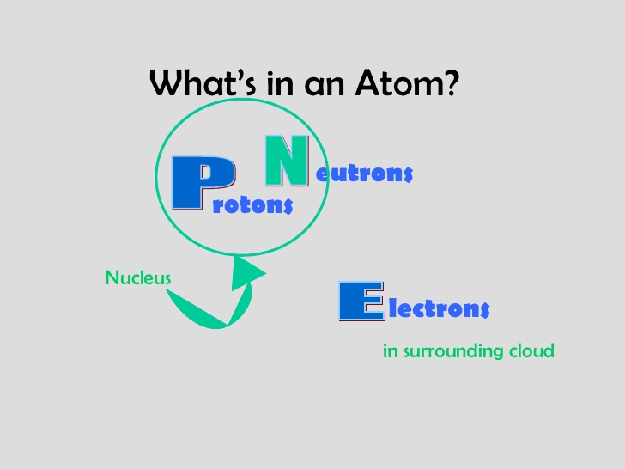](https://www.google.com/url?sa=i&rct=j&q=&esrc=s&source=images&cd=&cad=rja&uact=8&ved=0ahUKEwjK9fLY7OnWAhVDPxoKHZbNAFcQjRwIBw&url=https://www.slideshare.net/skyearth/apeman-and-atomic-theory&psig=AOvVaw00SayIA0WiKlhh29n-DCEh&ust=1507855249105738)

[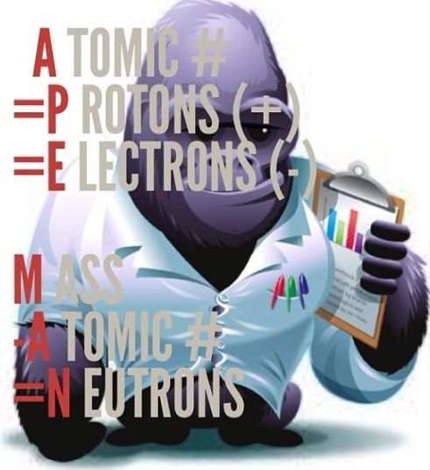](https://www.google.com/url?sa=i&rct=j&q=&esrc=s&source=images&cd=&cad=rja&uact=8&ved=0ahUKEwi5_czC7OnWAhVMXBoKHSjBDJwQjRwIBw&url=https://www.pinterest.com/pin/572801646327147305/&psig=AOvVaw3vqfxCG34duFbahamjdt3y&ust=1507855190924001)

[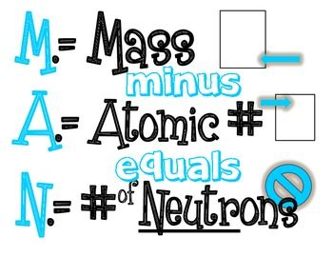](https://www.google.com/url?sa=i&rct=j&q=&esrc=s&source=images&cd=&ved=0ahUKEwjK9fLY7OnWAhVDPxoKHZbNAFcQjRwIBw&url=https://www.pinterest.com/pin/91409067414023710/&psig=AOvVaw00SayIA0WiKlhh29n-DCEh&ust=1507855249105738)

[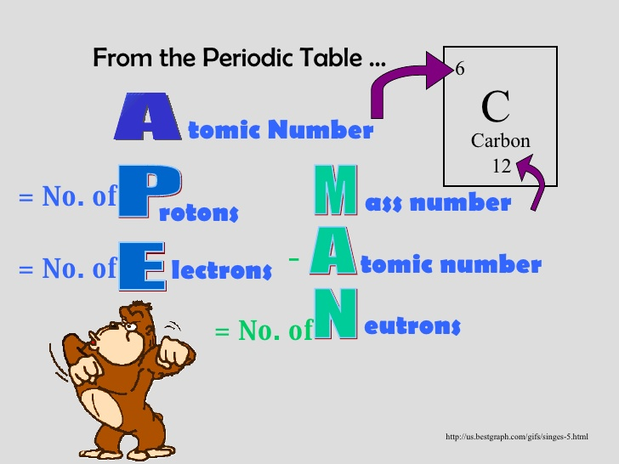](https://www.google.com/url?sa=i&rct=j&q=&esrc=s&source=images&cd=&cad=rja&uact=8&ved=0ahUKEwi1k4Db6-nWAhUH7hoKHYFVCr4QjRwIBw&url=https://www.slideshare.net/skyearth/apeman-and-atomic-theory&psig=AOvVaw2t1Mss6JKwIyMpFSbNijIT&ust=1507854989145274)